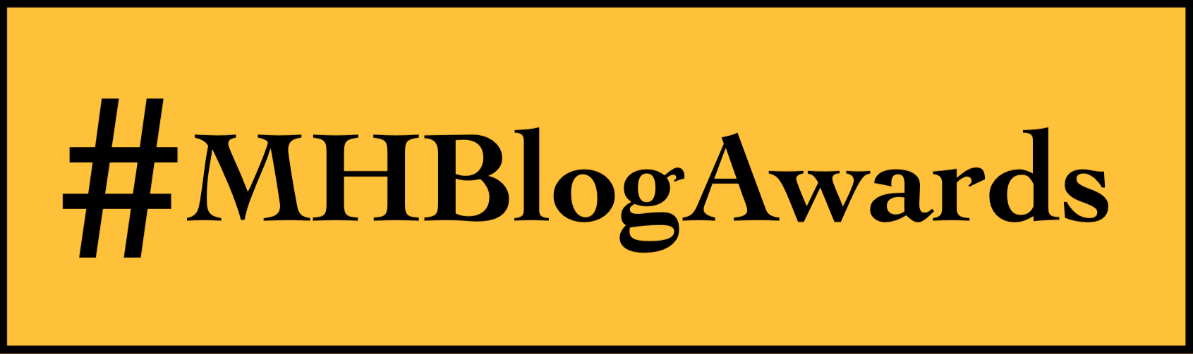
Speaker Application Form
Speaker/ Workshop sessions are prerecorded & have a 25 minute duration

Your Name & email address:
Topic/ title of your proposed session:
Overview of the content of your session:
Your social media/ website links (please only include links you are happy for us to share)
Is there anything that would make the event less accessible for you?

Please send completed forms to mhblogawards@gmail.com

